# **Name: Abdurrahman Qureshi**

# **Roll No: 242466**

Practical No: 3

Date Of Performance: 25/07/2025

Aim: To understand Continuous Integration by installing and configuring Jenkins with Maven to set up a build job

Part A

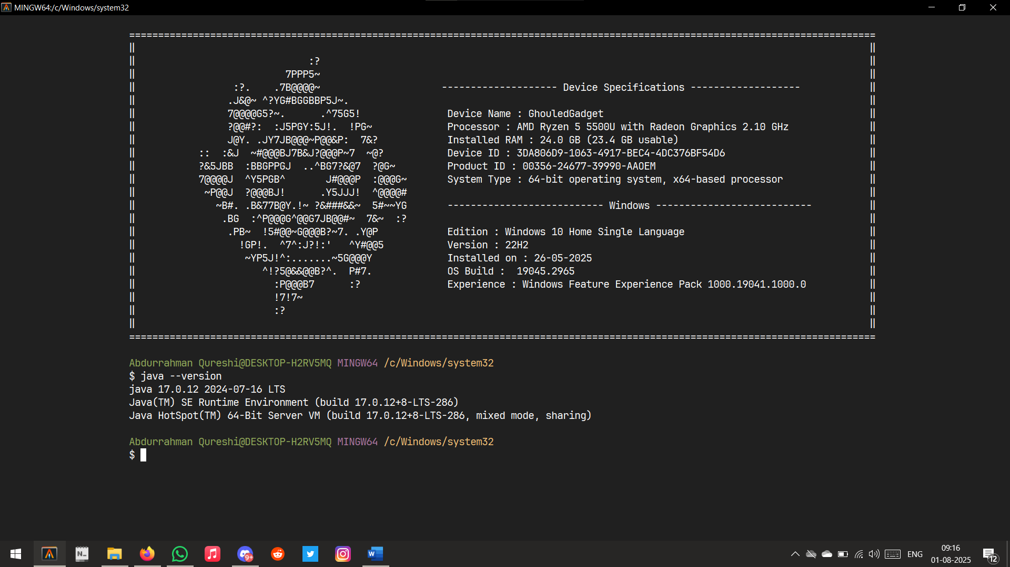

Checking JDK/Java Version

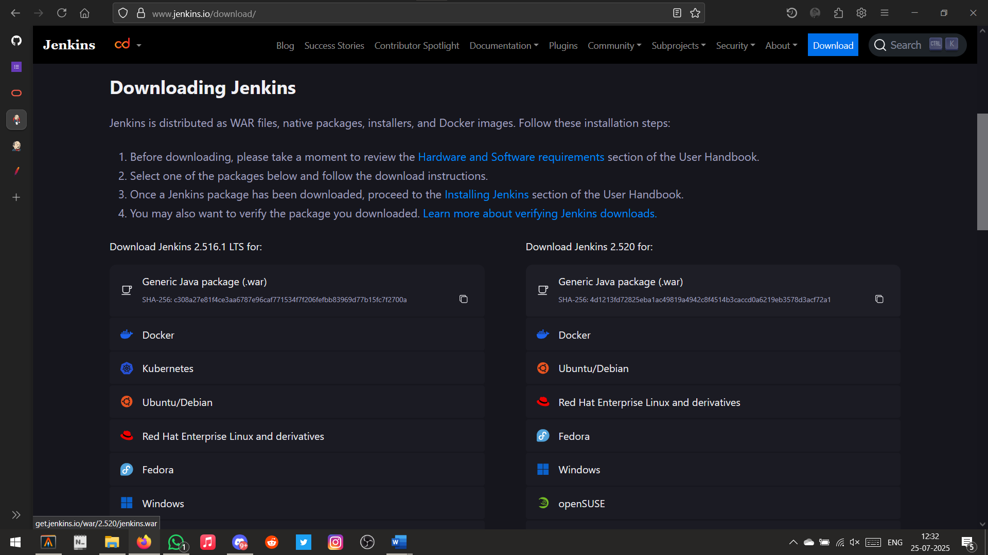

Downloading Jenkins

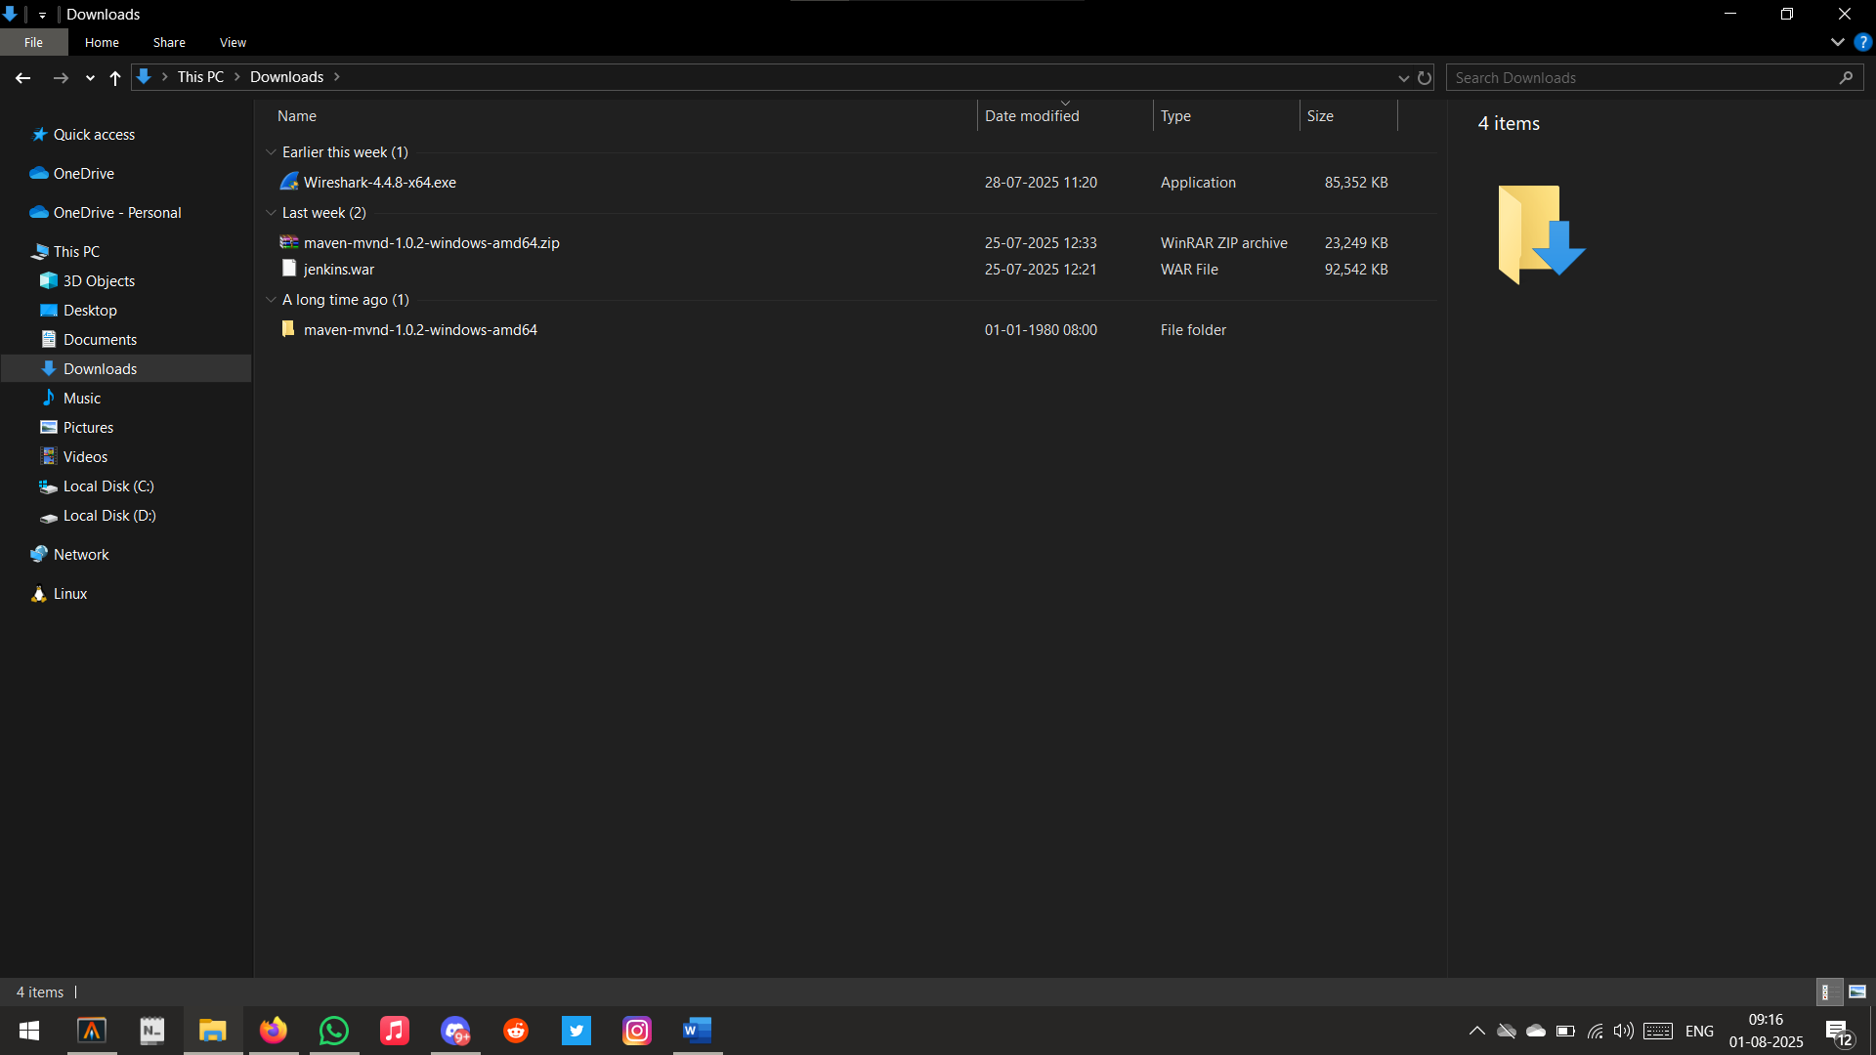

Jenkins Installed

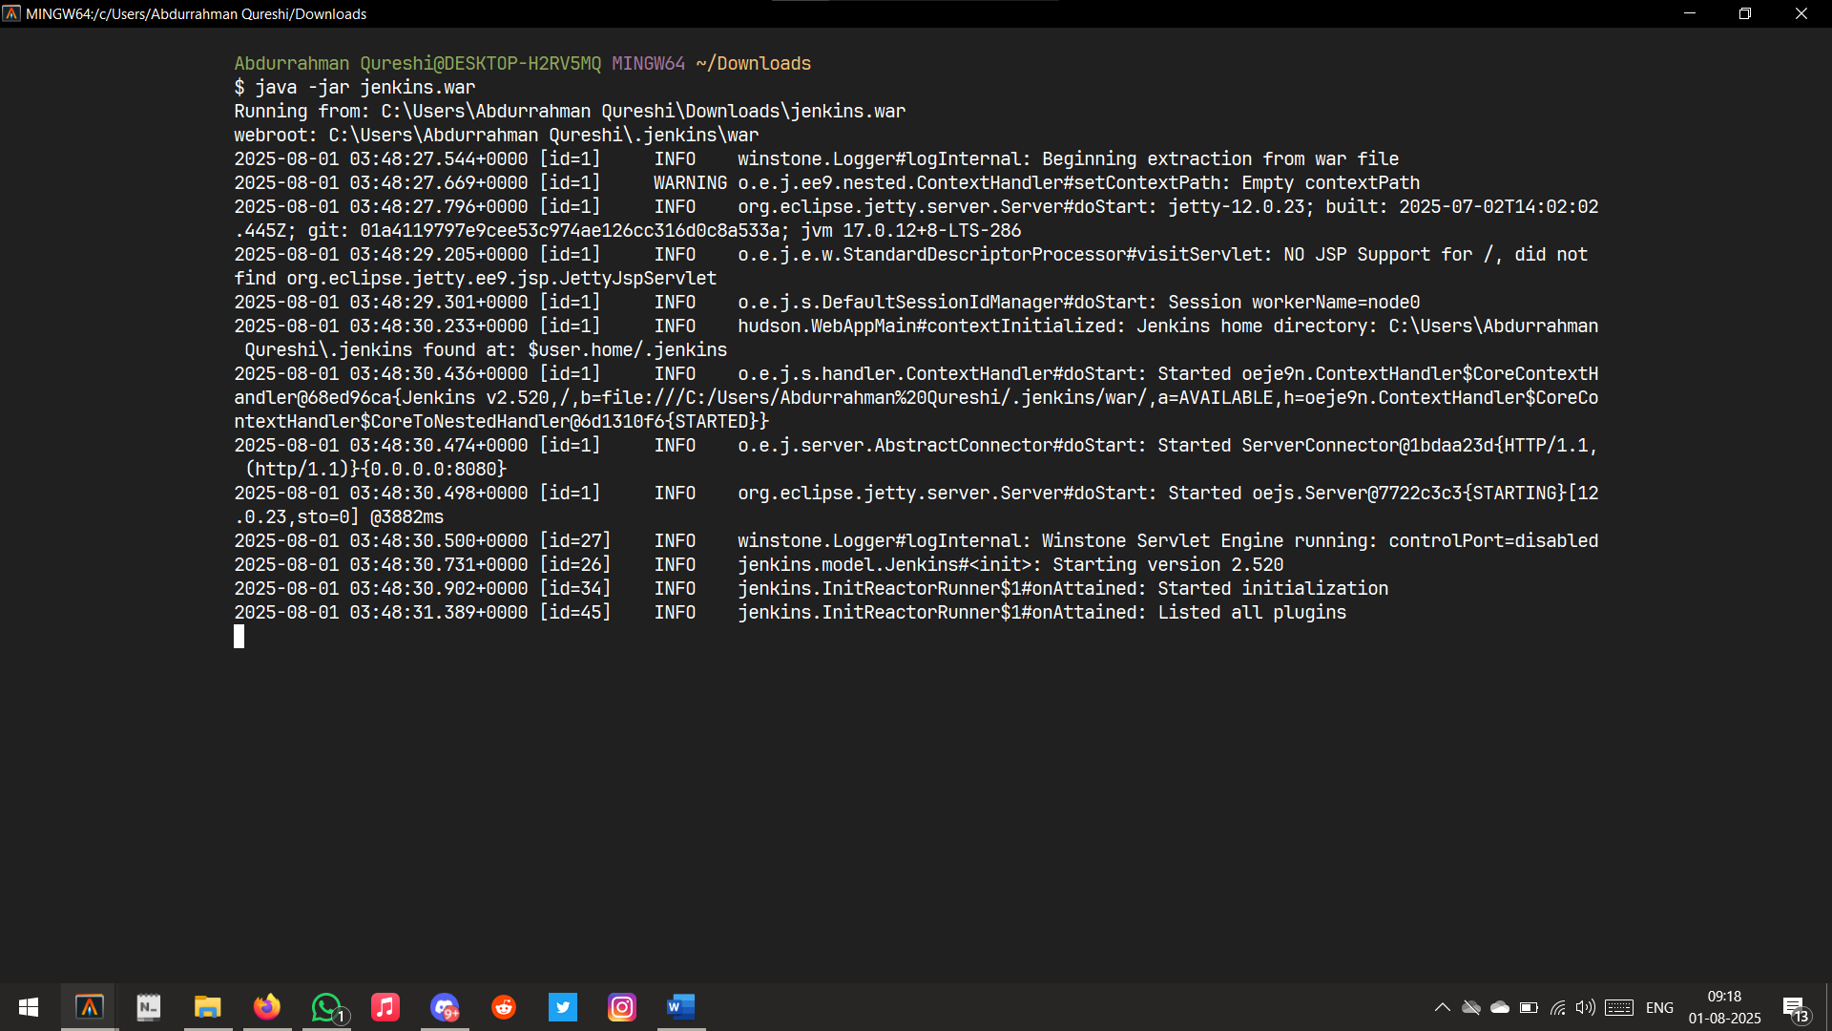

Access Jenkins in Browser (localhost:8080)

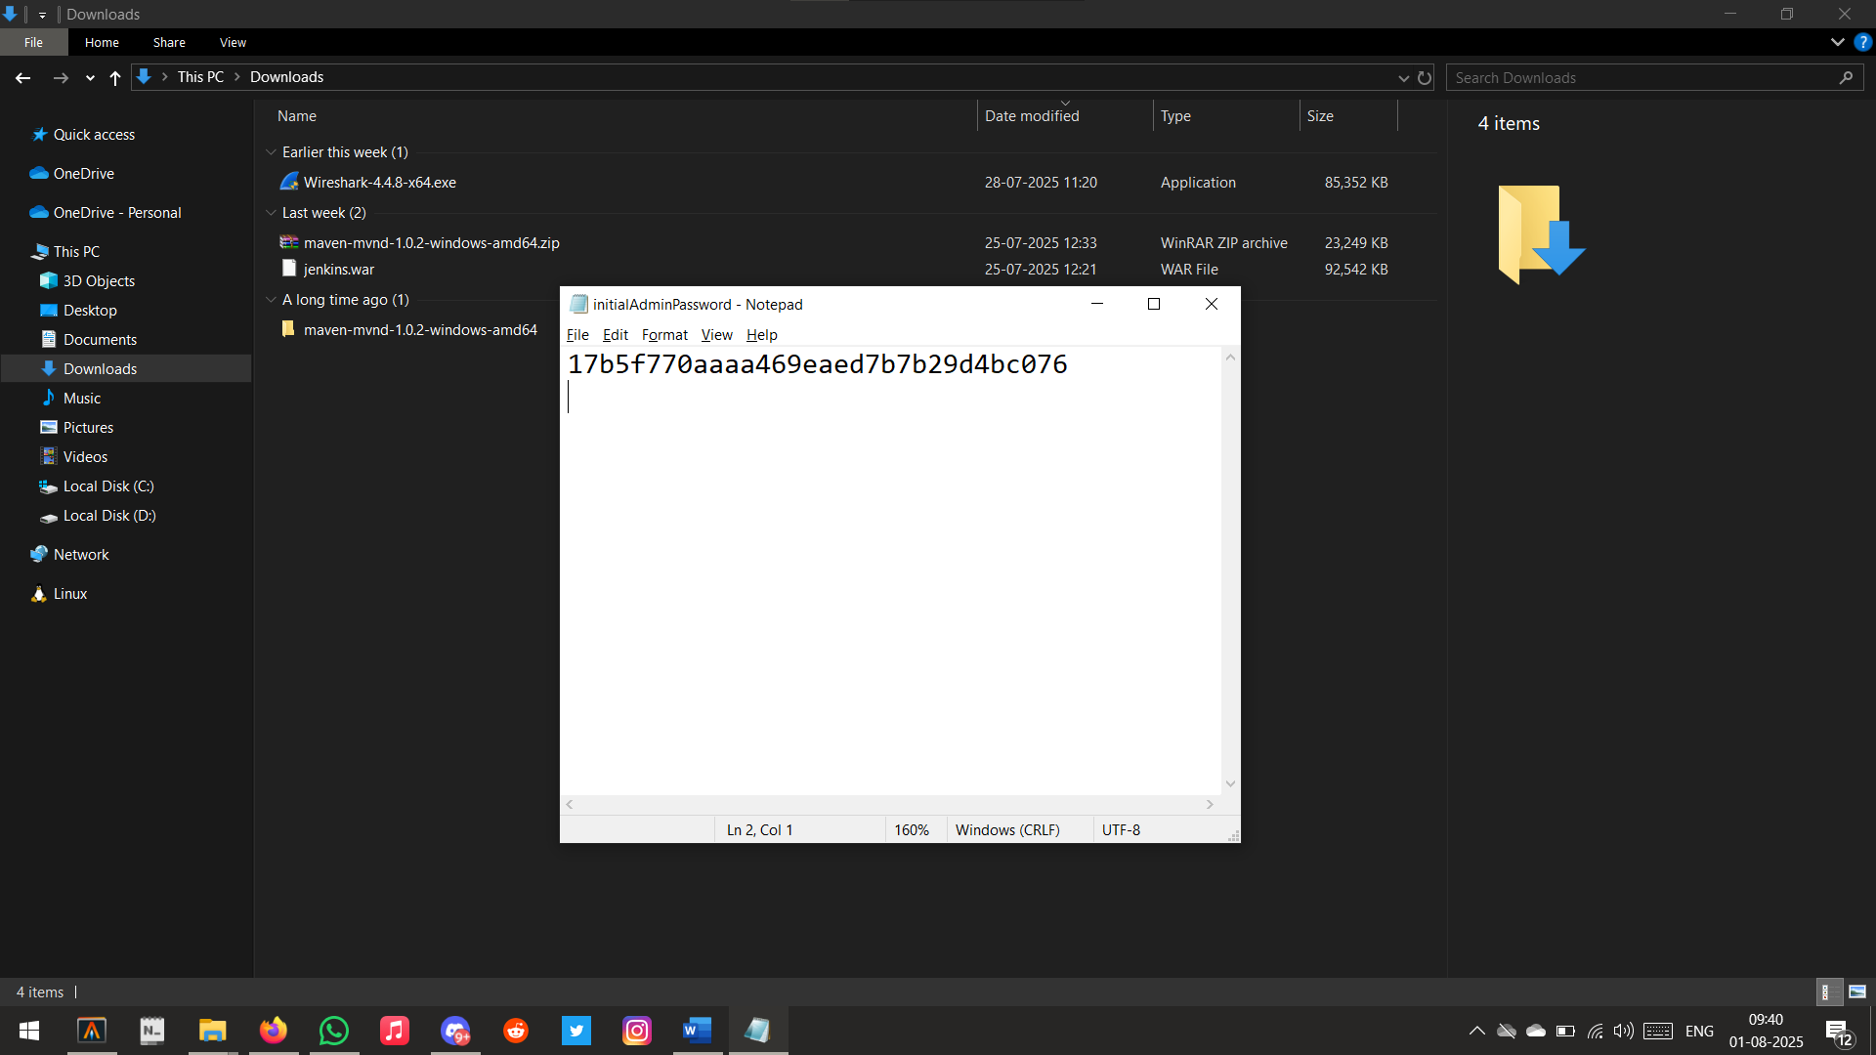

Initial Admin Password

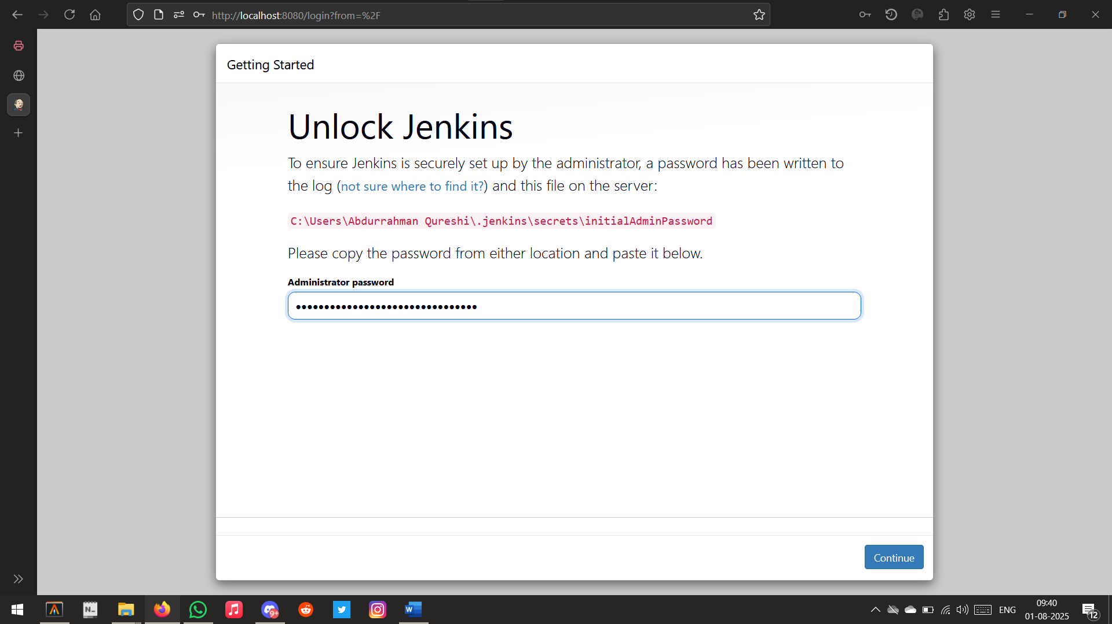

Inputting Password

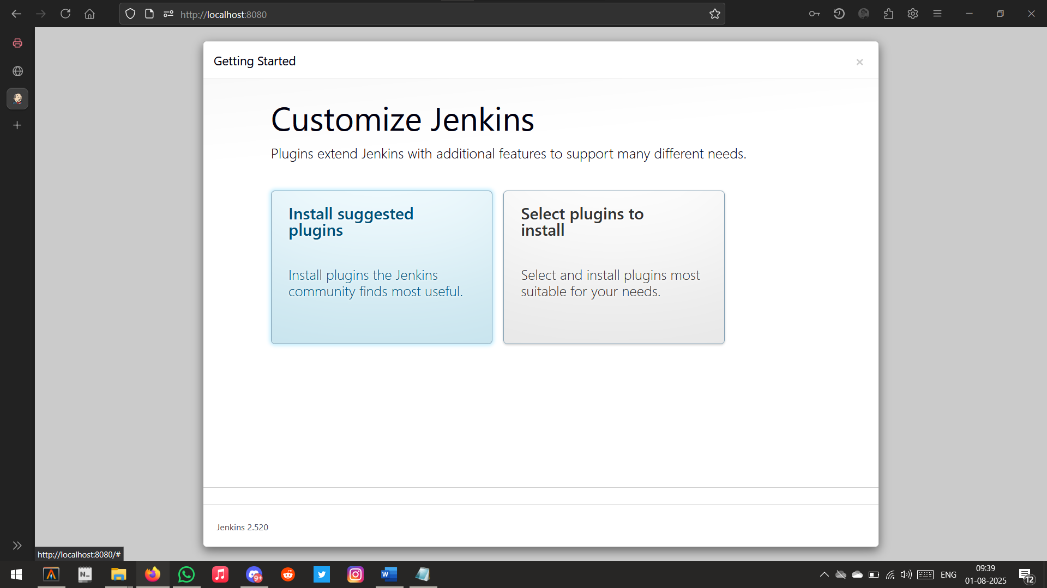

Setting up Plugins

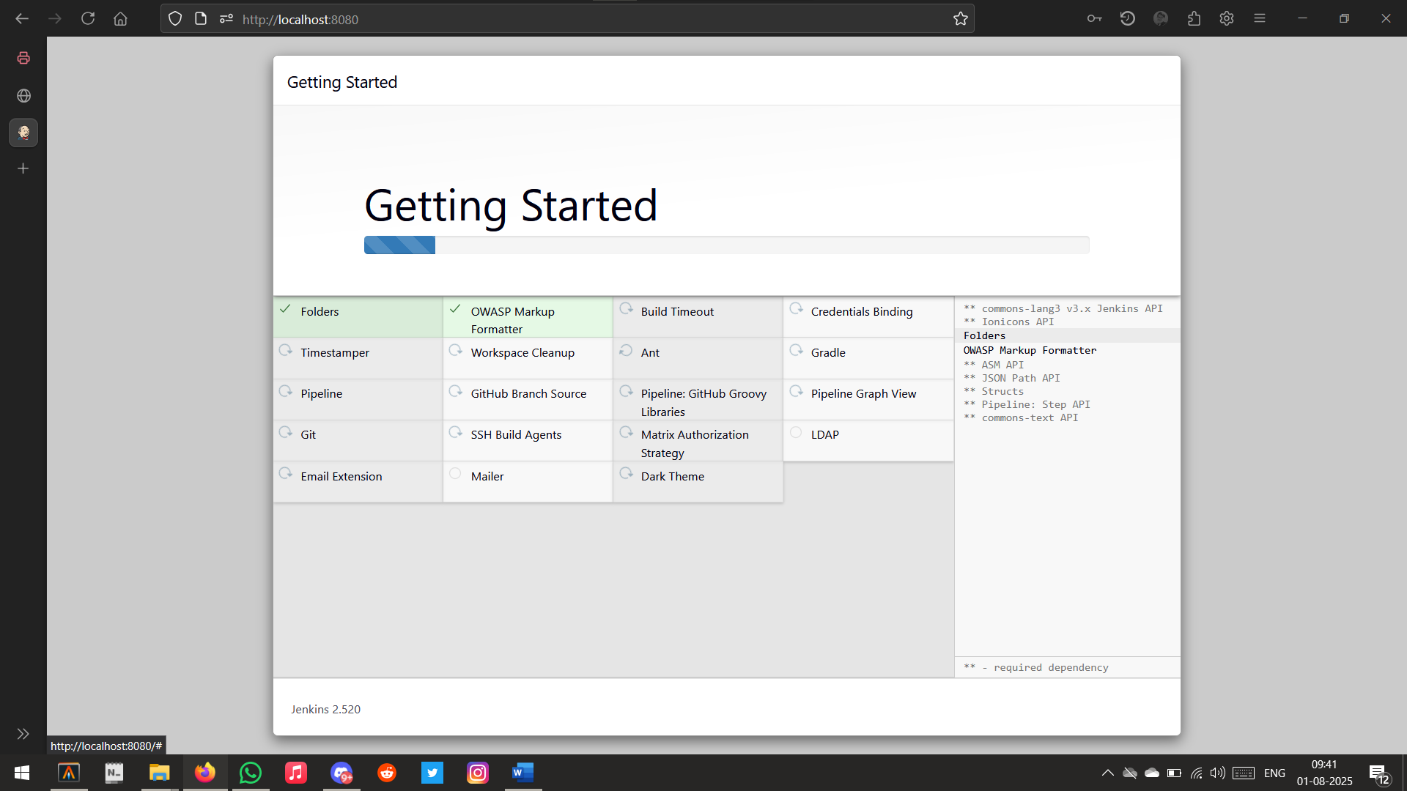

Installing Plugins

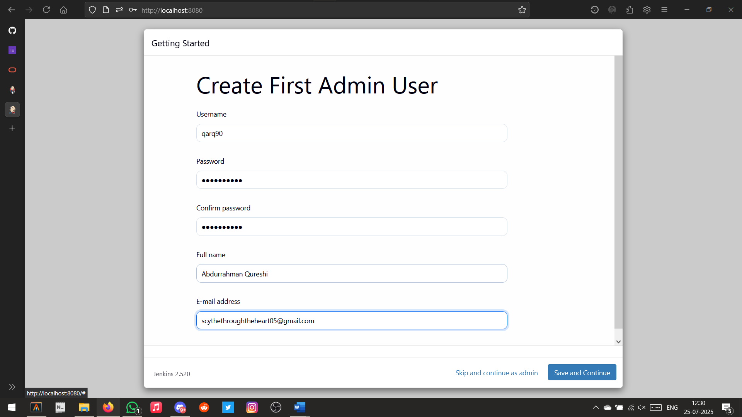

Setting First Admin User

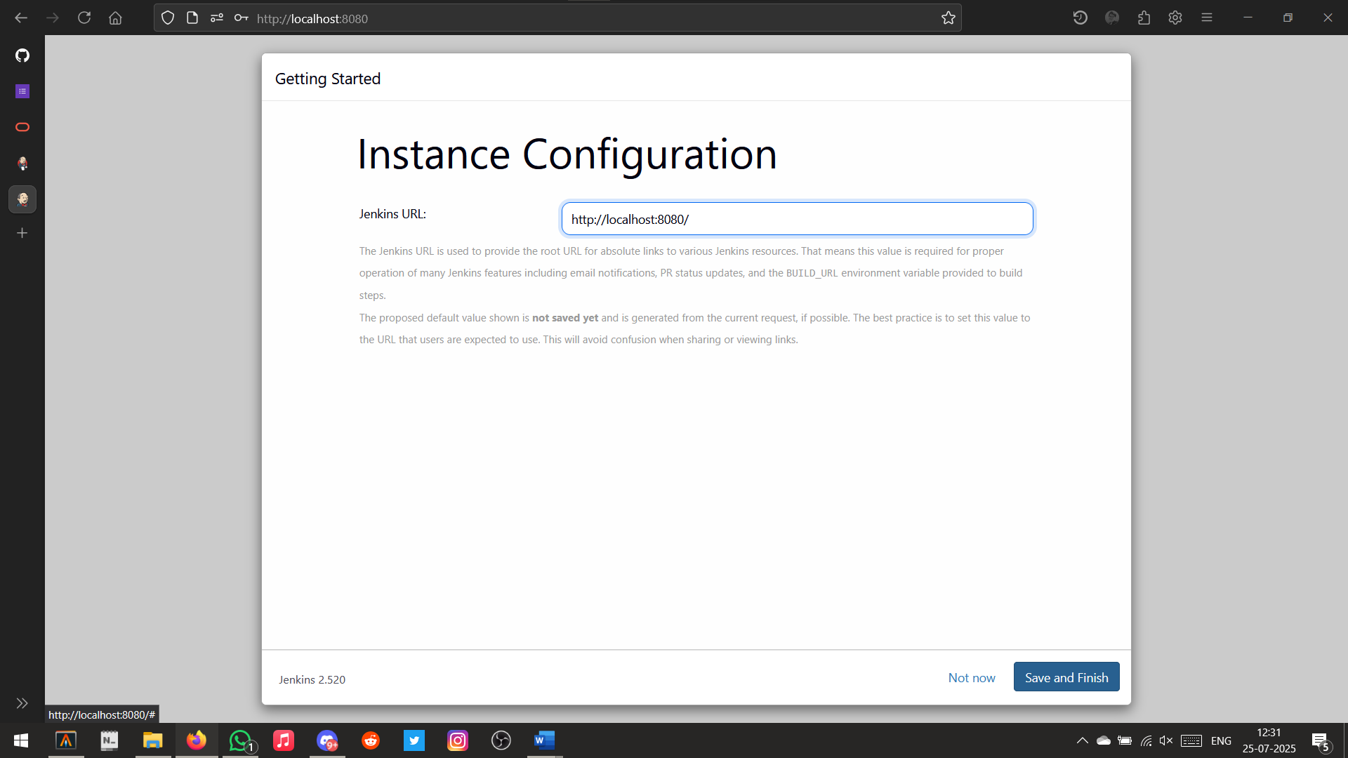

Setting Instance Configuration

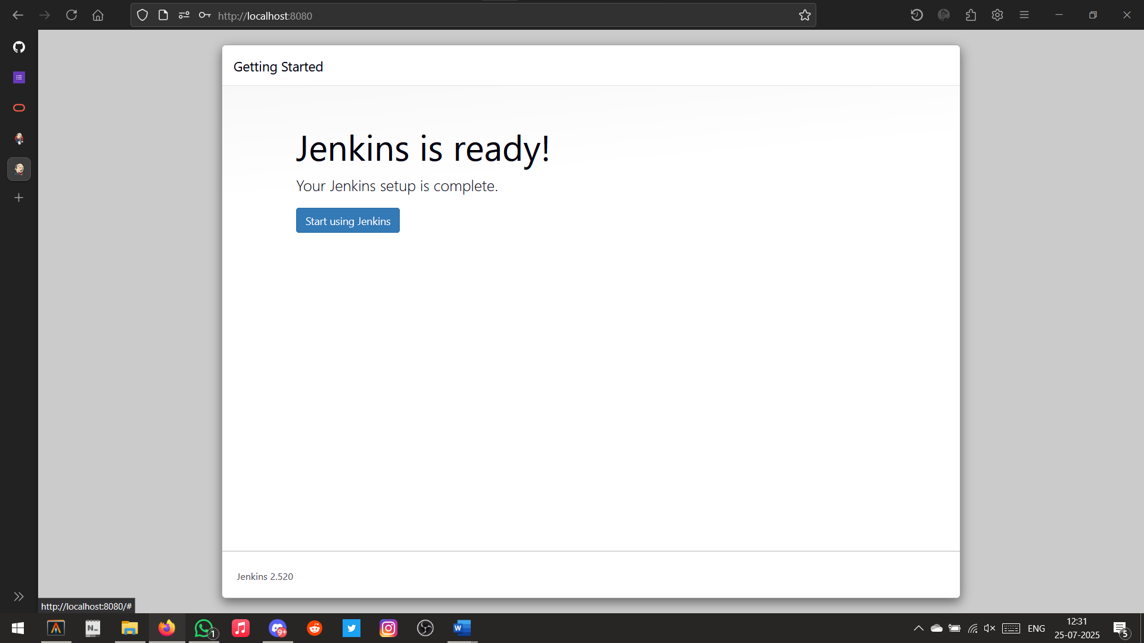Setup Successful

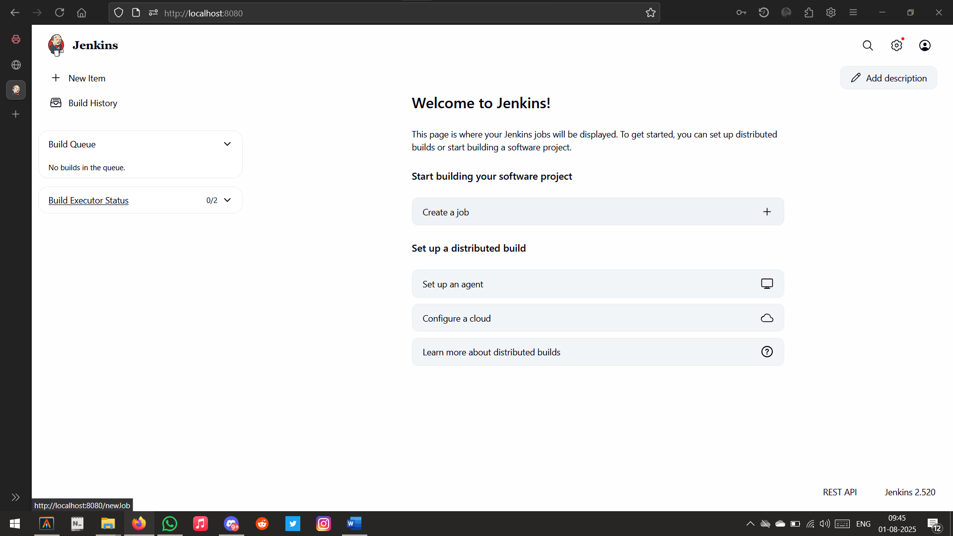

Jenkins Homepage

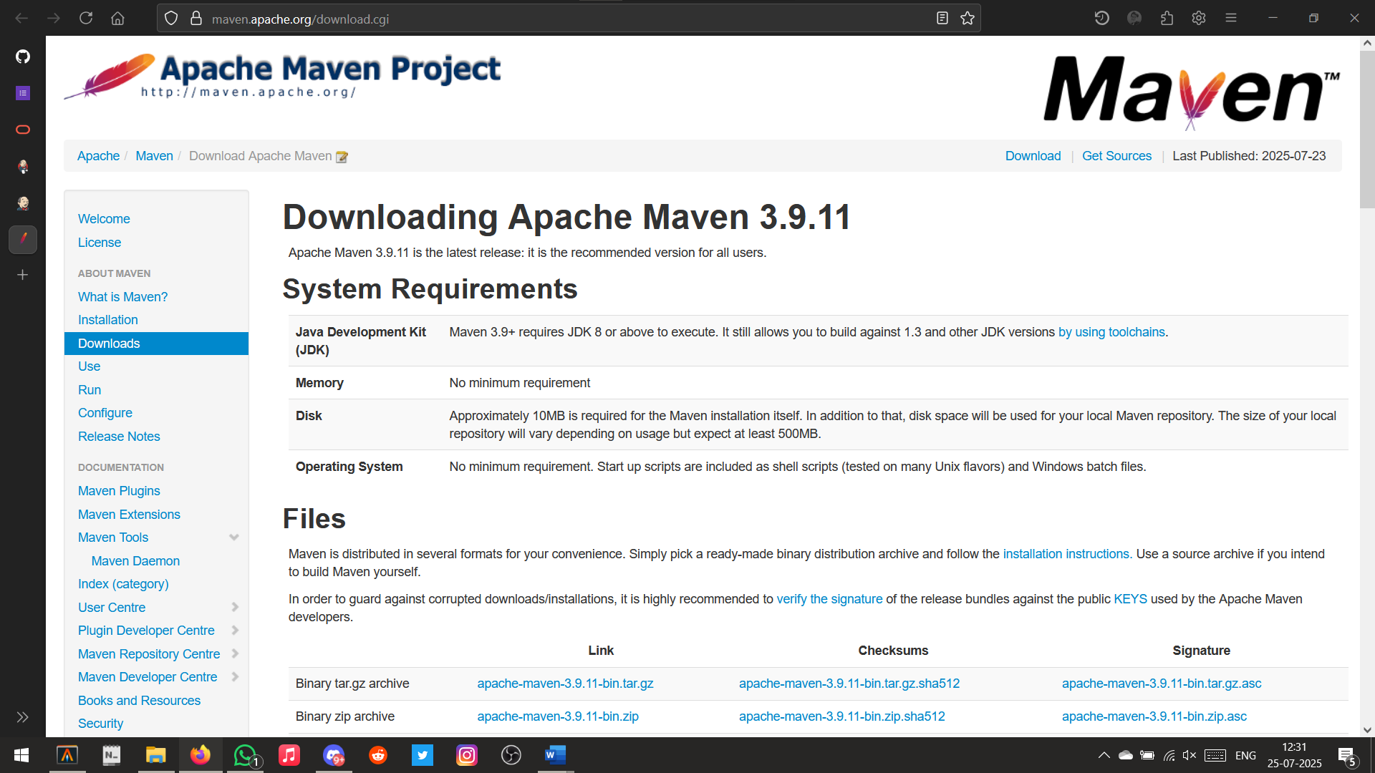

Downloading Maven

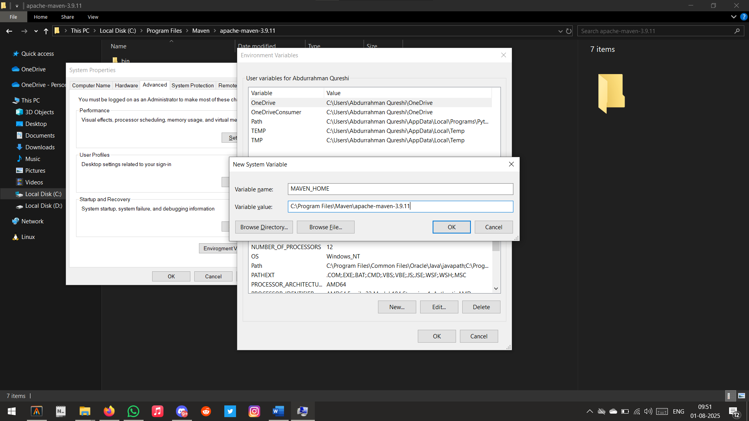

Setting System Path

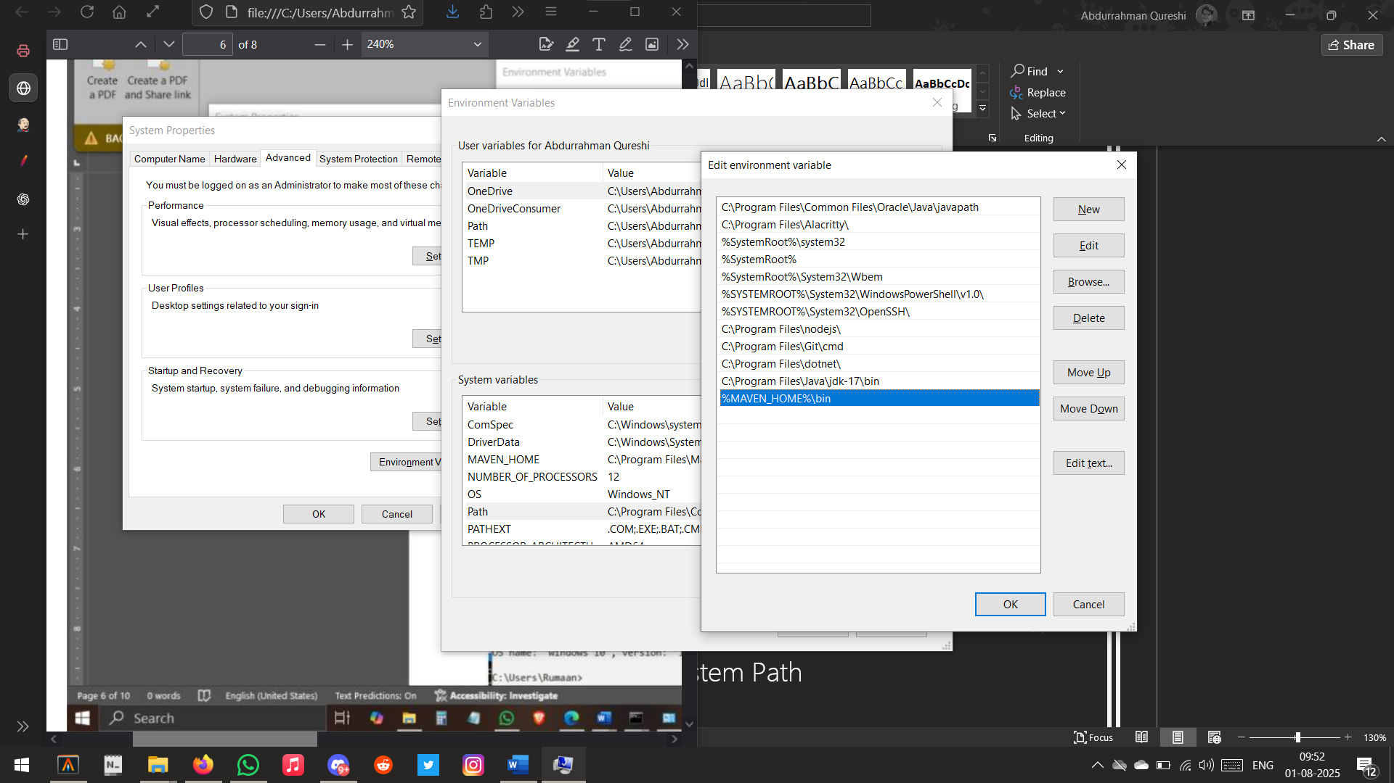

Setting Environment Path

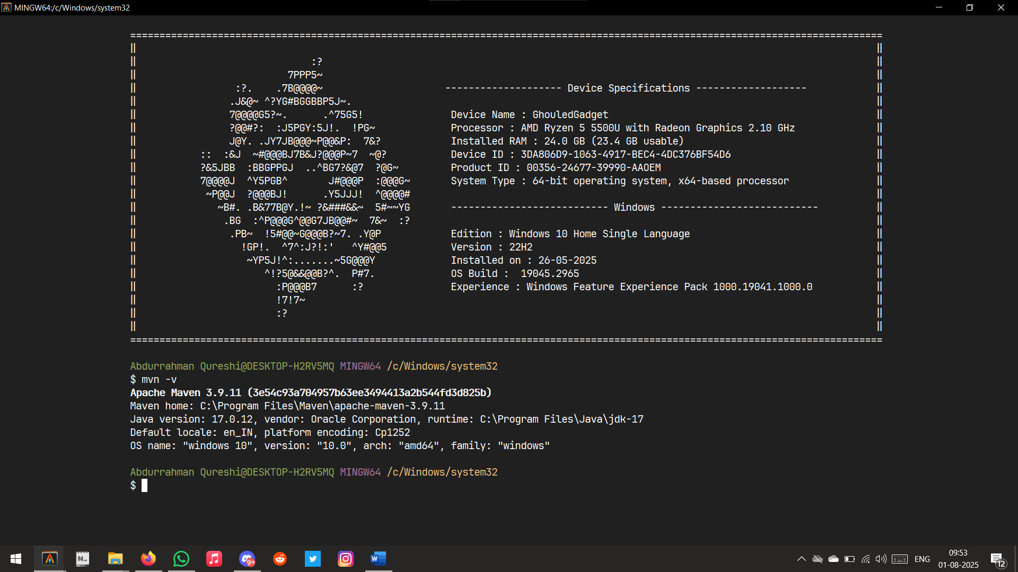

Validating Path

Part B

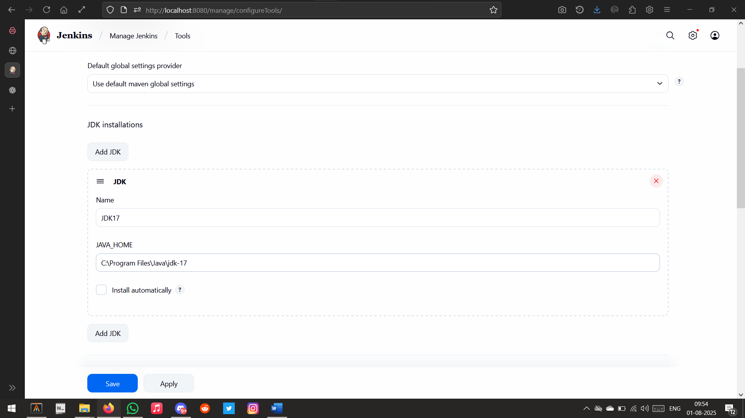

Setting up JDK

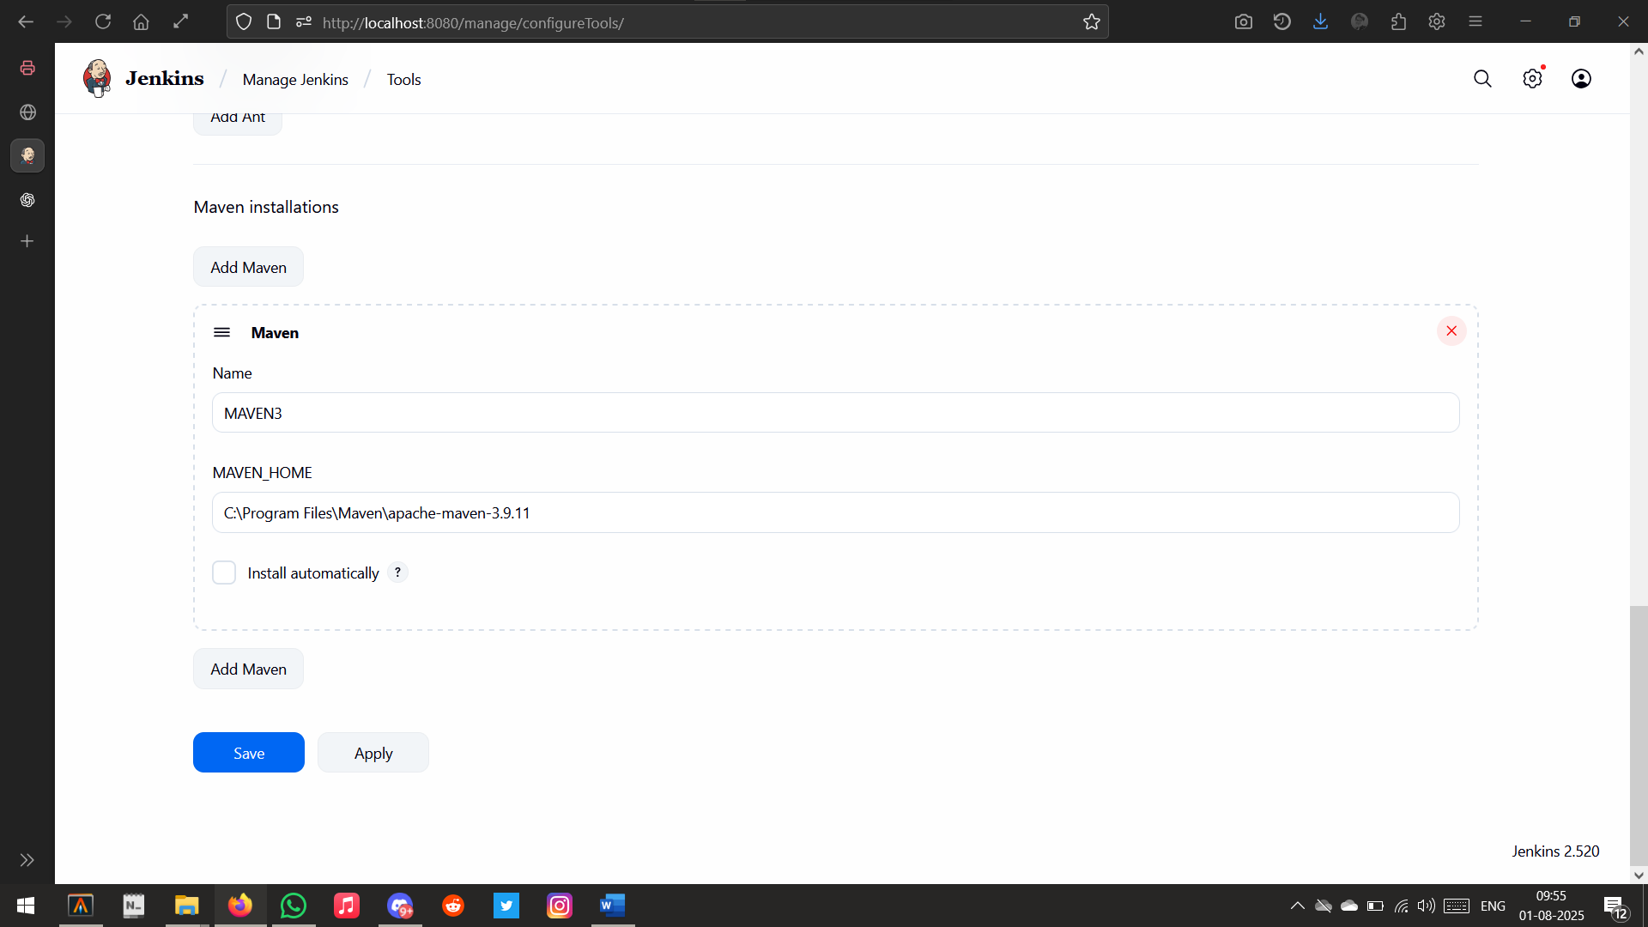

Setting up Maven

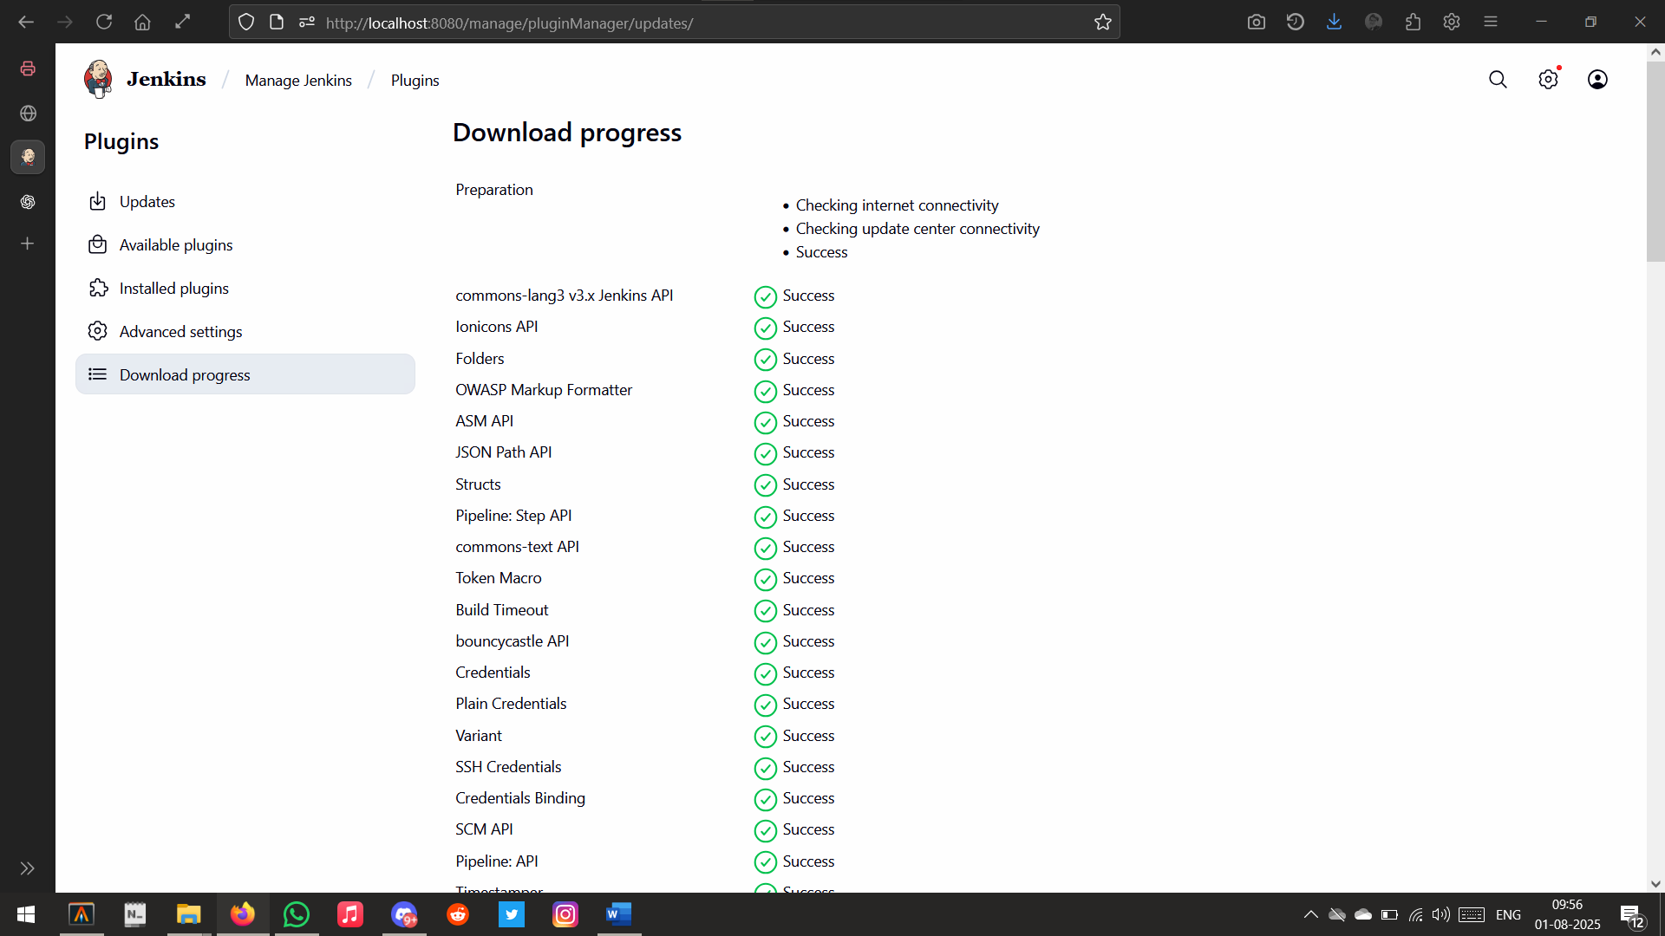

Checking Plugins

Conclusion:

We performed and understood continuous Integration by installing and configuring Jenkins with Maven to set up a build job.